Queen Elizabeth Dies At 96, Ending An Era For Britain
Britain's longest-reigning monarch, Queen Elizabeth, the nation's figurehead, and a towering presence on the world stage for seventy years, has died peacefully at her home in Scotland on Thursday, aged 96.
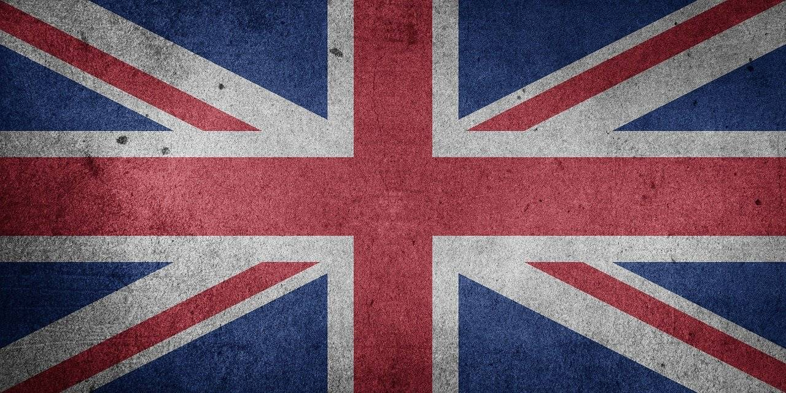
“The death of my beloved Mother, Her Majesty The Queen, is a moment of the greatest sadness for me and all members of my family,” the new king, her eldest son Charles, said.
“We mourn profoundly the passing of a cherished Sovereign and a much-loved mother. I know her loss will be deeply felt throughout the country, the Realms and the Commonwealth, and by countless people around the world,” the 73-year-old said in a statement, reported by Reuters.
News that the queen's health was deteriorating emerged shortly after midday on Thursday when her doctors said she was under medical supervision, prompting her family to rush to be by her side.
The queen had been suffering from what Buckingham Palace had called “episodic mobility problems” since the end of last year, forcing her to withdraw from nearly all her public engagements.
Her last public duty came only on Tuesday, when she appointed Liz Truss prime minister. “The death of Her Majesty the Queen is a huge shock to the nation and to the world,” Truss said outside her Downing Street office where the flag, like those at royal palaces and government buildings across London, were lowered to half-mast.
Queen Elizabeth II was the world's oldest and longest-serving head of state. She came to the throne following the death of her father, King George VI, on February 6, 1952. She was aged just 25 and crowned in June the following year. The first televised coronation was a foretaste of a new world in which the lives of the royals were to become increasingly scrutinized by the media.
“I have in sincerity pledged myself to your service, as so many of you are pledged to mine. Throughout all my life and with all my heart I shall strive to be worthy of your trust,” she said in a speech to her subjects on her coronation day.
In the following decades, Elizabeth witnessed massive political change and social upheaval at home and abroad. Her own family's tribulations, most notably the divorce of Charles and his late first wife Diana, were played out in full public glare. While remaining an enduring symbol of stability and continuity for Britons at a time of relative national economic decline, Elizabeth also tried to adapt the ancient institution of monarchy to the demands of the modern era.
“She has managed to modernize and evolve the monarchy like no other,” her grandson Prince William, who is now heir to the throne, said in a 2012 documentary.
Her reign repeatedly broke records for British rulers. When she surpassed the more than 63 years her great-great-grandmother Queen Victoria spent on the throne, she said it was not a landmark to which she had ever aspired. “Inevitably a long life can pass by many milestones – my own is no exception,” she said.
Her marriage to Prince Philip lasted 73 years, until his death in April 2021, and they had four children, Charles, Anne, Andrew and Edward.
“In her public duties she was selfless and wise, with a wonderful generosity of spirit. That is how she lived – and how she led,” former Prime Minister John Major said. “For millions of people – across the Commonwealth and the wider world – she embodied the heart and soul of our nation, and was admired and respected around the globe.”

